Session 17 – SMO Tools: Chatbots, Scheduling & Content Calendar
Q1. Sign up for ManyChat and create a simple chatbot flow that replies with a welcome message when a user says 'Hi' on Facebook Messenger.
Answer:
Tool: ManyChat
Objective: Automatically welcome users who send “Hi” to a Facebook business page.
Chatbot Setup Steps
- Open ManyChat and create an account.
- Connect the Facebook Page you manage and authorize the required permissions.
- Open the automation or flow builder.
- Create a keyword trigger for “Hi” and, if supported, include variations such as “Hello” and “Hey”.
- Add a Messenger message step with the welcome message below.
- Connect the trigger to the message and test the flow.
Sample Chatbot Flow:
Trigger
User sends: “Hi”
Automated Welcome Message
“Hi! 👋 Welcome to Foodie Express. Thanks for messaging us! 🍕 Would you like to explore our menu, check today's offers, or contact our support team?”
Quick Replies
- View Menu
- Today's Offers
- Contact Support
Expected Result: When a user sends “Hi,” the chatbot automatically sends a welcome message and provides options to help the user.
Note: This is the planned flow. You will need to create and test it in your ManyChat account; I have not connected or configured your account.
Q2. Use the free version of Buffer or Hootsuite to schedule two Instagram posts for the next week, each with a different caption and image.
Answer:
Selected Tool: Buffer
Objective: Schedule Instagram content in advance to maintain a consistent posting routine.
Sample Scheduling Plan
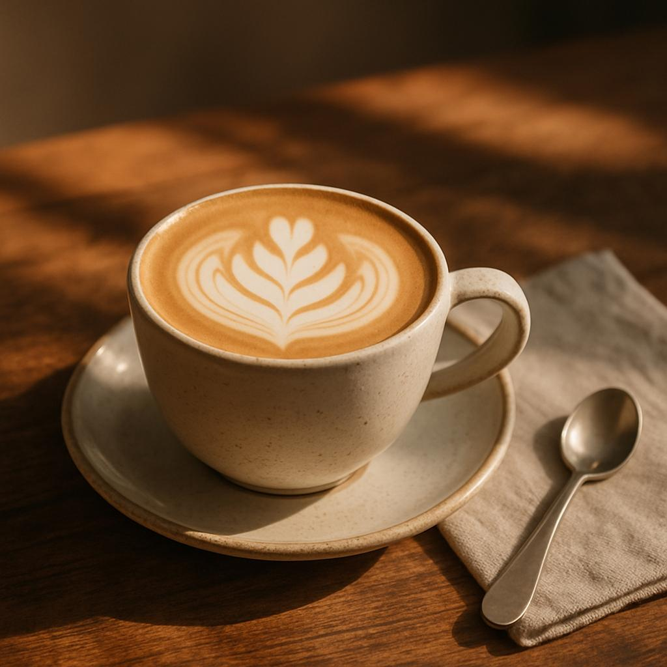
Post 1 – Monday, 2 November 2026
Suggested time: 11:00 AM IST
Image: A coffee cup with attractive latte art.
Caption:
“Monday mood = coffee first! ☕✨ Take a little break and make your day better, one sip at a time. Tag your coffee partner!”
Hashtags: #CoffeeLovers #CafeVibes #MondayMood
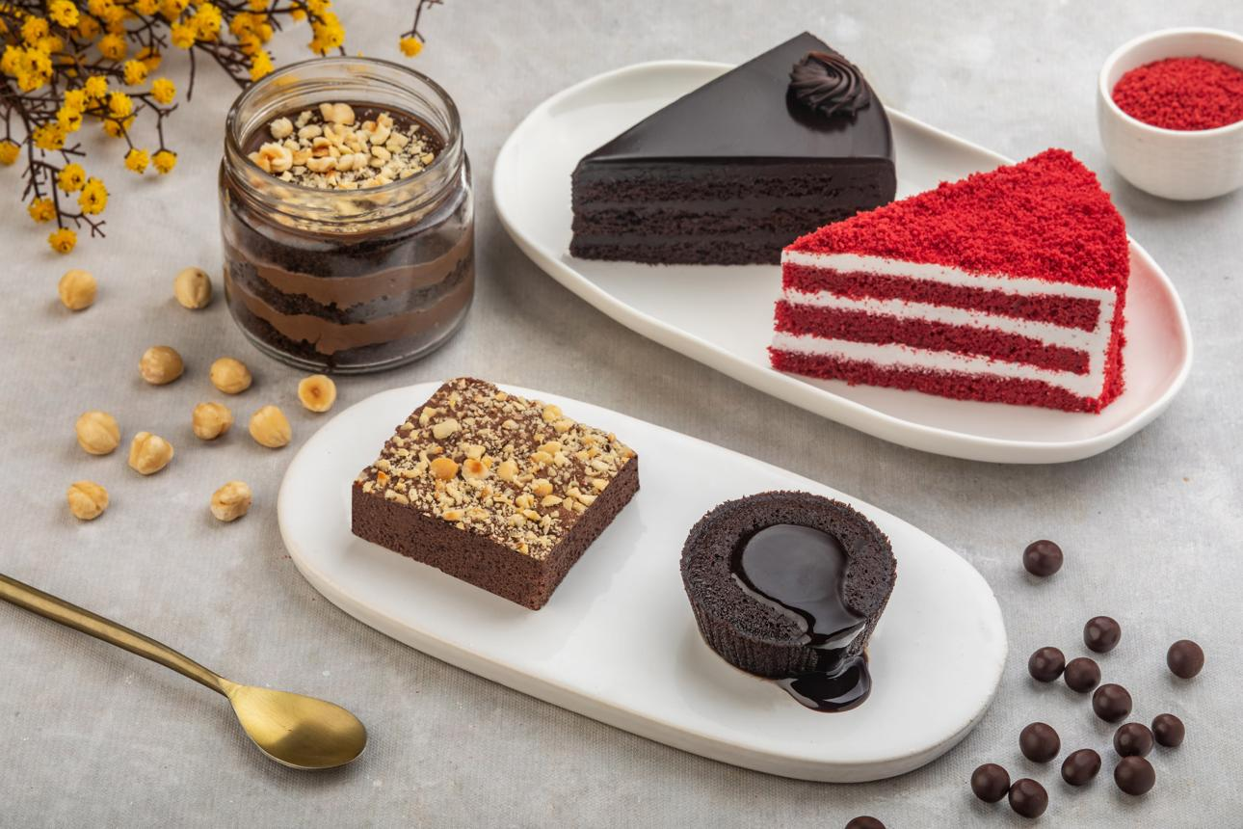
Post 2 – Thursday, 5 November 2026
Suggested time: 6:00 PM IST
Image: A delicious chocolate dessert platter.
Caption:
“A little chocolate makes everything sweeter! 🍫❤️ Which would you choose: a brownie or chocolate cake? Tell us in the comments!”
Hashtags: #DessertLovers #ChocolateCravings #FoodieLife
Steps to Schedule
- Create a Buffer account at Buffer.
- Connect your Instagram professional account, following the prompts.
- Create the first post and upload its image.
- Add the caption, hashtags, and scheduled date and time.
- Repeat for the second post with a different image and caption.
- Check the publishing queue to confirm both posts are scheduled.
Conclusion: Scheduling tools help businesses plan content in advance, save time, and maintain consistency. Actual scheduling and automatic publishing depend on the account type, permissions, and current free-plan limits.
You've hit the Free plan limit for image generations requests. You can create more images when the limit resets in 24 hours.
I couldn't generate the separate Instagram Story image for Task 4 right now. The earlier generated images are assignment-board mockups, not proof that any accounts or posts were actually created.
Q3. One-week content calendar for a food delivery app
Answer:
Day | Platform | Post Topic | Content Type | Suggested Time
Monday | Instagram | Popular food deals | Image Post | 12:00 PM
Tuesday | Facebook | New restaurant launch | Image Post | 11:00 AM
Wednesday | Instagram | Street food cravings | Reel | 7:00 PM
Thursday | X (Twitter) | Customer review | Text + Image | 10:00 AM
Friday | Instagram | Special weekend offer | Story | 1:00 PM
Saturday | Facebook | Funny food meme | Image Post | 5:00 PM
Sunday | X (Twitter) | Top 5 dishes in Ahmedabad | Video Post | 11:00 AM
These are suggested posting times. The business should use its own analytics to find when its audience is most active.
Q4. Create a promotional Instagram Story image for a new playlist launch
Answer:
Playlist Name: TuneVibes – Chill Vibes
Story Text:
- Main headline: NEW PLAYLIST LAUNCH!
- Supporting text: Chill Vibes for Better Days
- Features: Music for study, work, relaxation, and travel.
- CTA: Listen Now
Design Instructions for Canva:
- Open Canva and select the Instagram Story template (1080 × 1920 px).
- Choose a purple and blue gradient background with a sunset or music-themed visual.
- Add a smartphone, headphones, and music-note graphics.
- Add the headline and playlist name in large, readable text.
- Add a “Listen Now” button and your actual playlist link using Instagram's link sticker when publishing.
You can create and export this design manually in Canva. The separate image generation tool is currently unavailable.
Q5. Generate five creative post ideas for a small business and explain how to visualize each using Canva or CapCut.
Answer:
Selected Business: The Cozy Cup Café
No. | Post Idea | How to Visualize It
1 | Behind-the-scenes coffee making | Use a CapCut video template with short clips of brewing coffee and adding latte art.
2 | Customer testimonials | Create a Canva quote graphic featuring genuine customer feedback, with permission where needed.
3 | Special menu highlight | Design a Canva poster featuring a popular coffee or dessert with its name and price.
4 | Seasonal café offer | Use a festive Canva template with attractive food photography and clear offer details.
5 | Café atmosphere | Create a CapCut Reel showing the café interior, seating, drinks, and ambience with background music.
Conclusion: Canva is useful for creating attractive graphics and promotional posters, while CapCut is suitable for editing short videos and Reels. These tools help a small café maintain consistent branding and create engaging social media content.
